

**Degitraffic**

Bachelor’s/Master’s thesis

Month 20XX

Degree Programme/Master’s Degree Programme Specialisation (if applicable)

2

**ABSTRACT**

Tampere University

Mafruha Nuhary

Maruf Rayhan

Fahid Ahmed Khan

3

**CONTENTS**

|  |  |  |
| --- | --- | --- |
| 1 | INTRODUCTION .................................................................................. | 6 |
| 2 | REPORT LAYOUT................................................................................ | 8 |
| 3 | UML DIAGRAMS................................................................................. | 11 |

6

**1 INTRODUCTION**

In this software project, an application is built which will monitor how the weather affects road maintenance and condition. This application will be the combination of a weather app and a road condition monitor. This application will not only provide information about the road status affected by the weather as well as the weather conditions.

This document will record the design process of the software. A detailed view of the software prototype and future decisions about building the software will be stated in this design document. Firstly, the whole prototype will be shown and then the different components, modules, and classes will be described. The document will serve to show the big picture.

8

**2 REPORT LAYOUT**

The main page of the application contains a menu bar. The dash bar gives the users various action options. Users can check road reports, weather reports, weather and road combined reports, the option to select preferred location as default, option to download compare and report.

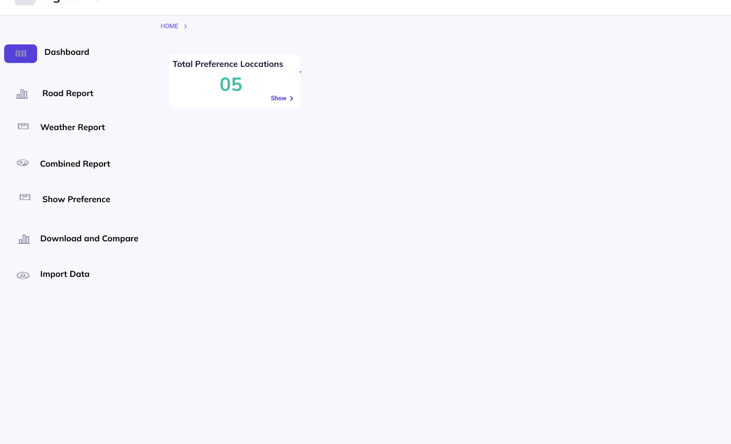

PICTURE1: Main Page.

**Road Report**

The road report option allows users to view different road conditions. Once the user clicks on this option, they will be given three options road maintenance, road condition, or recent traffic alerts.

1. Road maintenance: If the user selects the road maintenance option, it will first ask the user to fill out information regarding which road they want to view.

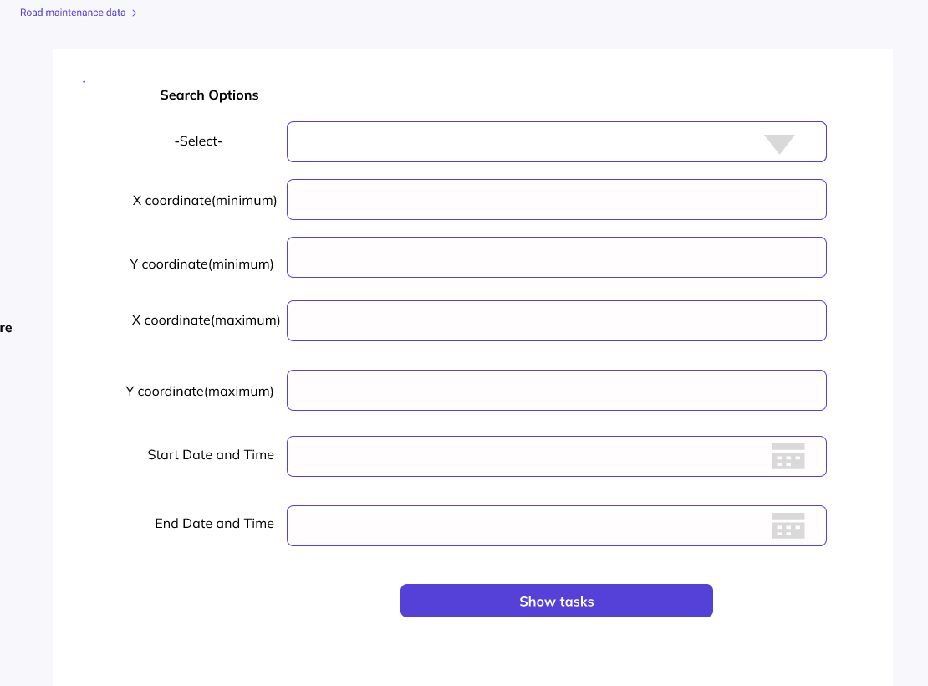

PICTURE 2: Road maintenance data.

Users have to fill in the place, maximum and minimum coordinates, and timelimit. Users can select to view road maintenance information on a certain day and time through these options. The place selector has a scrollable list that looks like the picture below.

PICTURE3: Selectors.

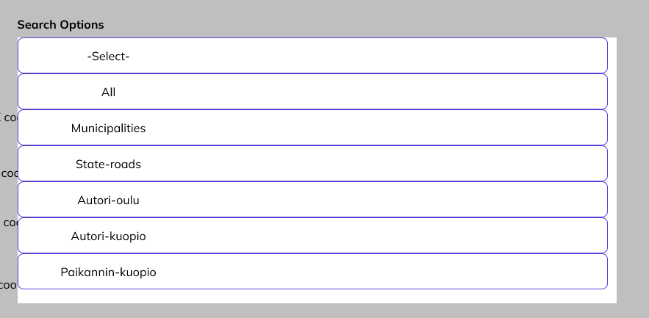

Once the user is satisfied they can proceed by pressing the “show tasks” button. The following page will show the road maintenance results based on the user-provided values. Users will be provided two different types of graphs to show the maintenance of the certain road. Users will also be able to edit or modify their results by providing new information to the form again which will also be visible on this page. The application also keeps records of the places searched by the users.

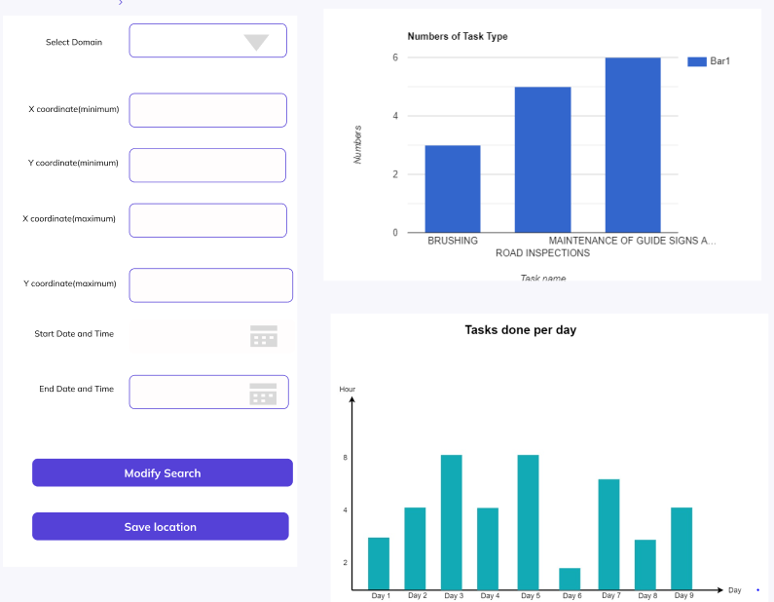

PICTURE4: Road maintenance result.

1. Road condition: Once the user selects the road condition option from the road report they will be guided to a new page where there are fields for selecting visibility, friction conditions, winter slipperiness, and duration as the last 2hr to 8hr. Once the users have selected the required fields, they can search results with the “search” button. The results will be the following, road temperature, actual temperature, wind speed, the direction of the wind, type, and reliability. Users can modify their search with the new information in the required fields on this page.

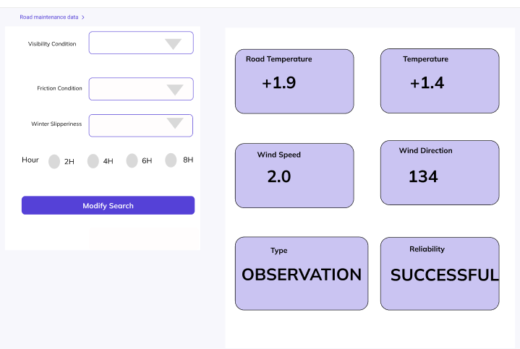

PICTUR5: Road condition result.

1. Traffic message: The traffic message option only requires two pieces of information from the users, time, and situation type.

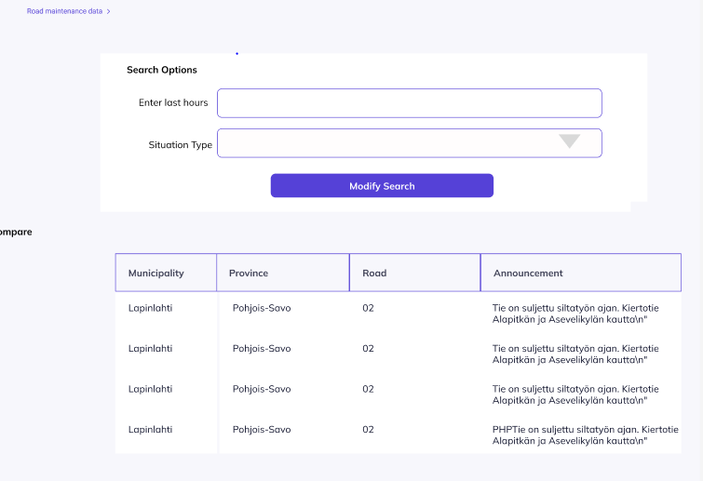

PICTURE6: Traffice message.

**Weather report**

Users can select the nearest station for a weather forecast through this option. Once a location is selected the application will show the latest weather conditions. It includes information about humidity UV index to sunset and sunrise. On this page, users will also find options, temperature, and humidity. Clicking one of these buttons will open a graph showing temperature or humidity throughout the day. Users can modify this graph by selecting hourly, daily, or average information.

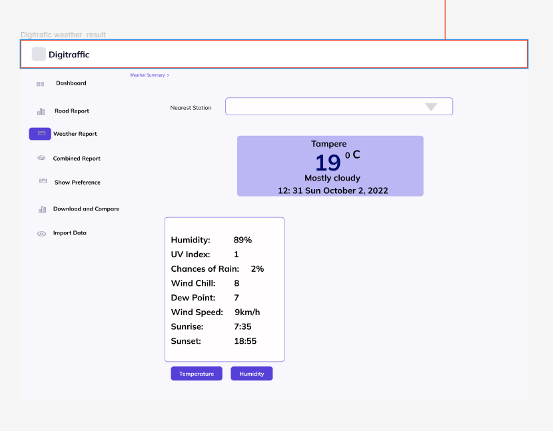

PICTURE7: Weather result.

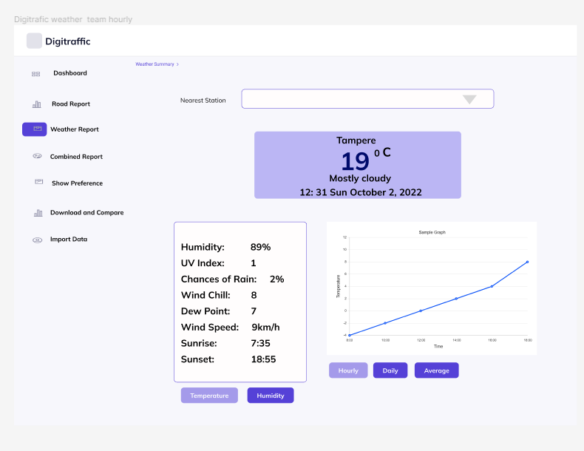

PICTURE 8: Weather report with graph.

**Combine report**

In the combined report the users can get their desired result by selecting the location, type of information, and duration. This gives the users a weather overview, road conditions based on the weather, and the latest announcement.

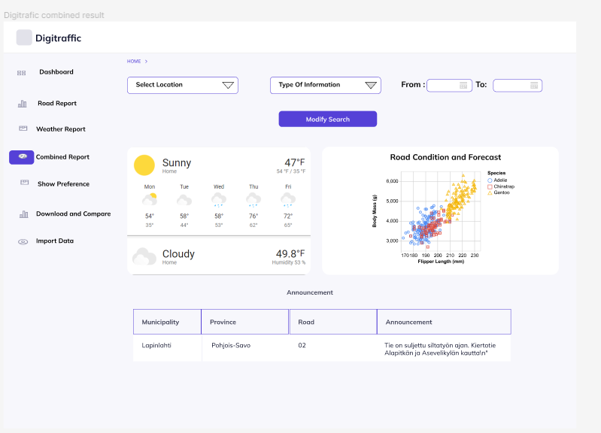

PICTURE 9: Combine report results.

**Show Preference**

This option allows users to select a default option.

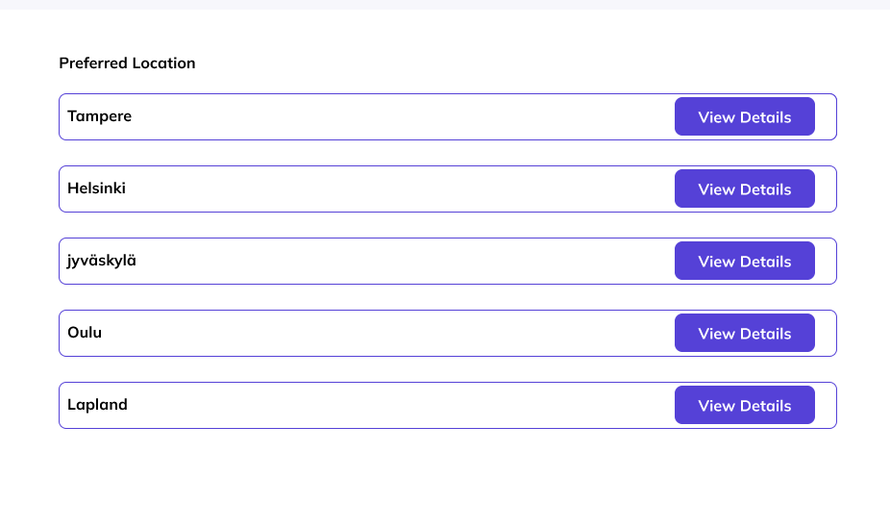

PICTURE 10: Sow preference page.

**Download and Compare**

Users also have the option to download weather data. The application can also compare the date if a user uploads a previously downloaded date.

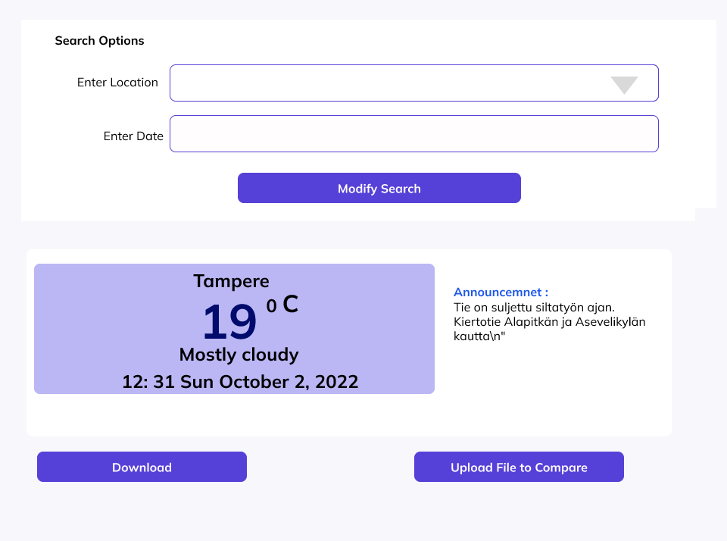

PICTURE 11: Download and compare page.

**Import data**

With the help of import data, users can upload files. They can make a report, and send in a picture with this option.

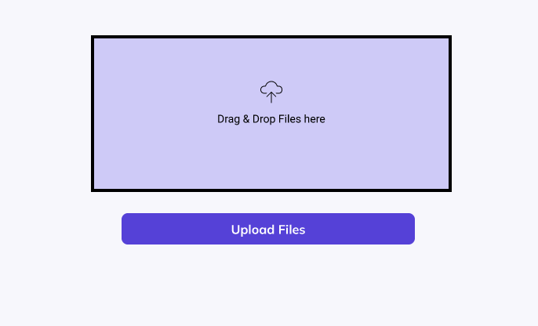

PICTURE 12: Import data page.

**3 DIAGRAMS**

* 1. **UML diagram**

The UML diagram shows a simple application. It shows all the possible actions available for the users in this project.

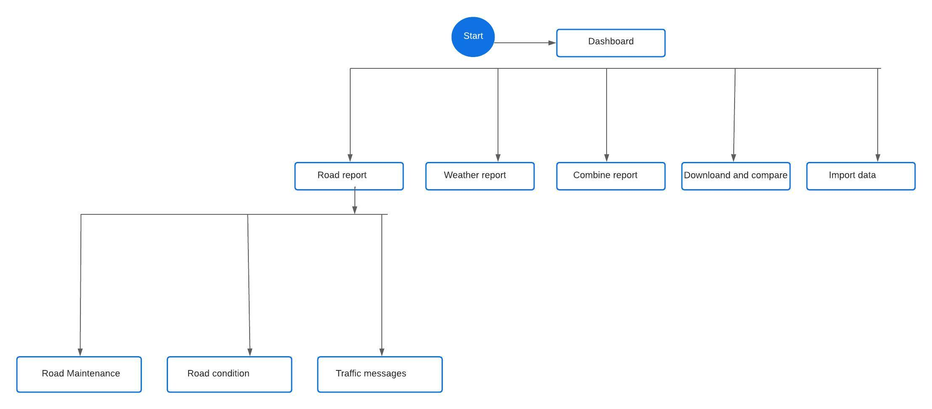

PICTURE 13: UML diagram.

* 1. **Class diagram**

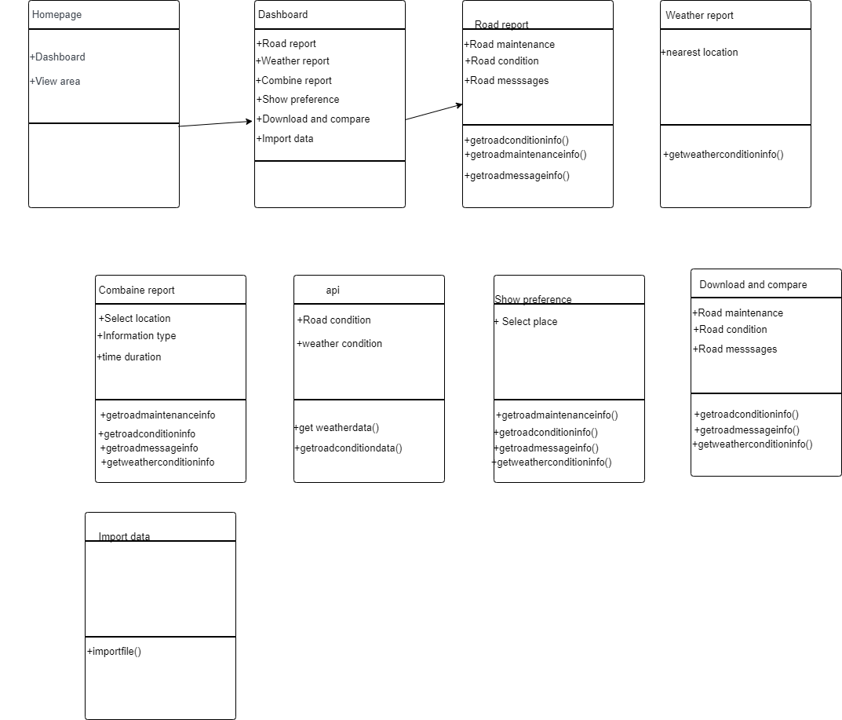

21